**Дата**: 12.12.2024

**Клас**: 5-А

**Предмет**: англійська мова

**Тема:** Новий рік.

**Мета:** : формувати навички вживання лексичних одиниць по темі; удосконалювати навички читання, аудіювання й усного монологічного мовлення; розвивати пізнавальні інтереси учнів; виховувати інтерес до самостійного пошуку потрібної інформації, а також загальну культуру учнів.

**Вчитель**: Руда Д.В.

Хід уроку

1.Greeting

Good afternoon, guys! I’m glad to see you. Are you ready to start our lesson? All set?

2. Wаrm up / Listening

Уважно слухати аудіо трек і дати відповідь на питання вчителя <https://www.youtube.com/watch?v=-4QovTg5kCI> .

3. Speaking

Дати усно відповіді на питання :

Was the last year a good year for you? What were some of its highlights?

What wasn't good about this year for you?

What good or bad events happened in the world during the past year?

Did you achieve any goals in the past year? Did you keep resolutions that you made at the beginning of the year?

When does the new year start for you? From January 1st, or from a different day?

How do people in your culture celebrate the New Year? Is it usually a family celebration or more of a party with friends?

What is usually on television on New Year's Eve? On New Year's Day? Do you enjoy watching TV around this time of year?

In your culture, do people give cards or gifts at the New Year? If so, to whom do you send cards or give gifts?

Do you associate any special foods with the end or the beginning of the year? What are they?

What are your plans for New Year's Eve? Who will you spend the time with?

4. Повторення

Повторити фразу to be into something/to be good at smth/to be interested in smth.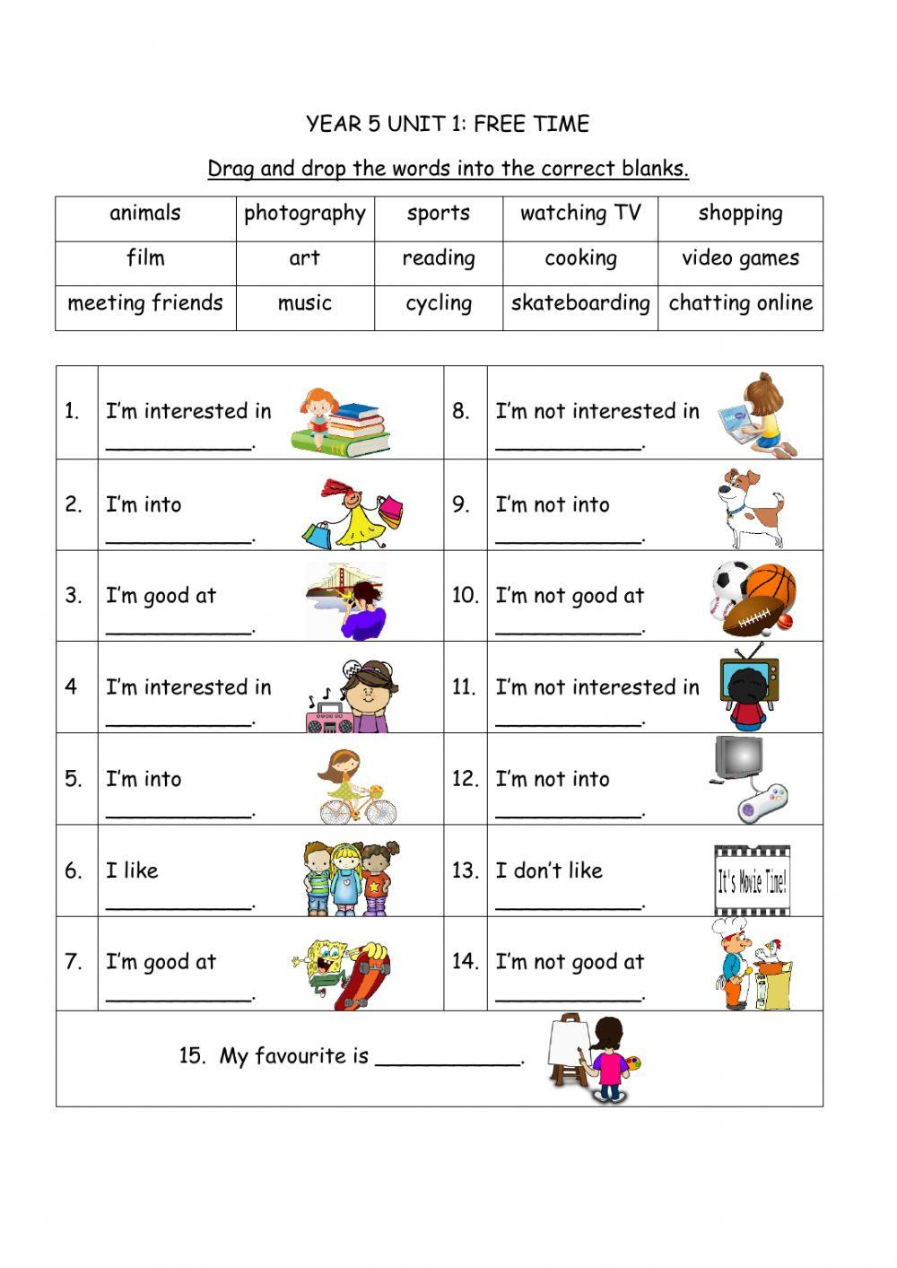

Повторити celebrations.

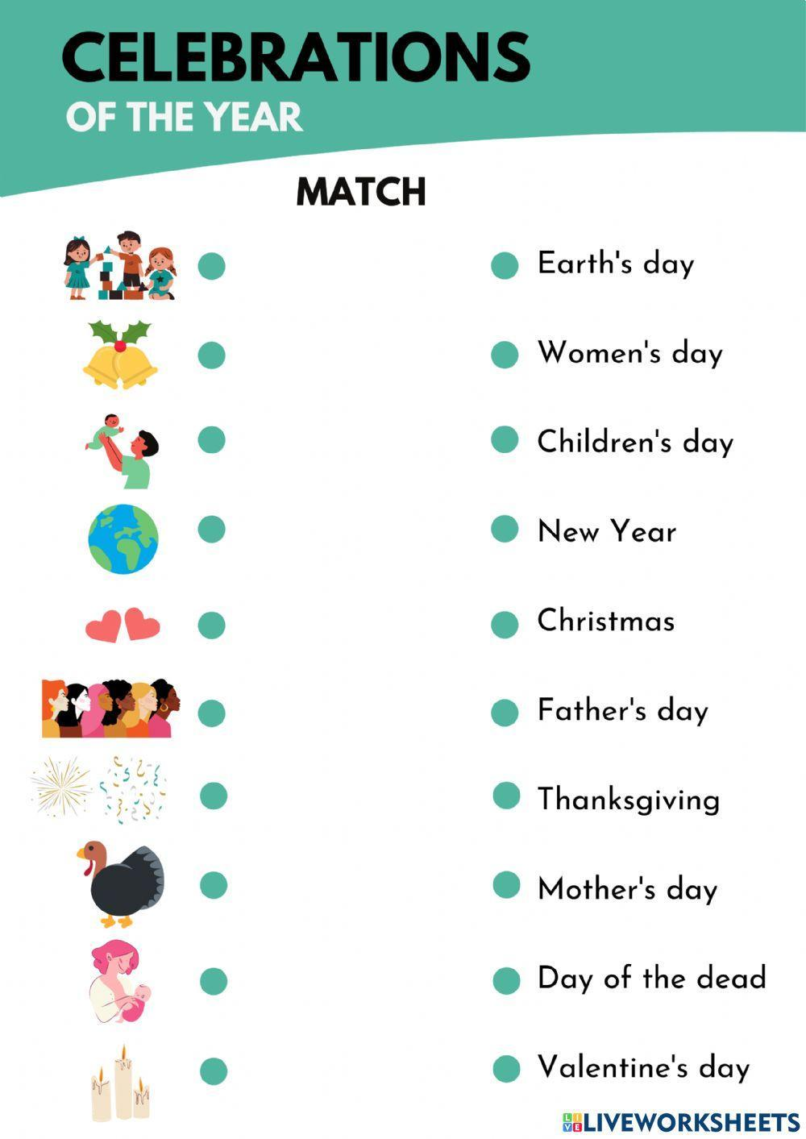

5. Writing

Виконати письмово вправу 4 стр 66.

6. Homework

1. Виконати вправу 1,2 стр 67.

2. Повторити irregular verbs стр 150-151.